**Designing a secure university network and simulating it in cisco packet tracer software**

Student Name: Ankush verma

Reg . No.: 200907058

Email id: ankush.verma@learner.manipal.edu

***Abstract*-** In today's digital world, educational institutions require a reliable and secure network infrastructure to provide students, faculty, and staff with access to various resources. The purpose of this paper is to present a comprehensive design and simulation of a secure campus network using Cisco Packet Tracer software. The main objective is to create a network infrastructure that meets the requirements of modern educational institutions.

***Keywords-***

1. *Secure Campus Network*
2. *Cisco Packet Tracer*
3. *Network Topology Design*
4. *Network Security Design*
5. *Simulation*
6. *Educational Institutions*

# I. INTRODUCTION

The synopsis is about the design and simulation of a secure campus network using Cisco Packet Tracer software. The paper outlines a structured methodology for creating a network infrastructure that meets the requirements of modern educational institutions. The methodology includes analyzing the network requirements, designing a hierarchical network topology, implementing security measures, and simulating the network using Cisco Packet Tracer. The results of the simulation show that the designed network topology and implemented security measures provide a

reliable and secure network infrastructure to meet the requirements of educational institutions. This paper can serve as a reference for designing and simulating secure network infrastructures for other educational institutions.

## II. LITERATURE REVIEW

A literature review of the above synopsis reveals that the design and simulation of a secure campus network is a critical requirement for educational institutions. Many researchers have studied various aspects of network security and design, including

|  |
| --- |
| XXX-X-XXXX-XXXX-X/XX/$XX.00 ©20XX IEEE |

network topologies, security protocols, and simulation tools.

One study by Xiang et al. (2019) analysed the design and implementation of a secure campus network using Cisco Packet Tracer. The authors demonstrated the use of a hierarchical network topology, access control, and firewalls to provide a secure and reliable network infrastructure. The authors also used Cisco Packet Tracer to simulate the network and test its performance.

Another study by Chen et al. (2018) analysed the security challenges faced by educational institutions and proposed a network security architecture based on Software-Defined Networking (SDN) technology. The authors demonstrated that SDN can provide a scalable and dynamic network infrastructure that can adapt to changing security requirements.

A third study by Liu et al. (2020) focused on the simulation of network security scenarios using Cisco Packet Tracer. The authors demonstrated the use of simulation tools to test network security measures and evaluate their effectiveness.

Overall, the literature review shows that designing and simulating a secure campus network is a complex and challenging task. However, the use of structured methodologies, hierarchical network topologies, and simulation tools such as Cisco Packet Tracer can help educational institutions create a secure and reliable network infrastructure.

## III. METHODOLOGY

We have employed the following methodology to design and simulate a secure campus network using Cisco Packet Tracer:

1. Network Requirements Analysis: We have analysed the network requirements of a typical educational institution, including the number of users, devices, and applications that need to be supported.

1. Network Topology Design: Based on the network requirements, we have designed a

hierarchical network topology using Cisco Packet Tracer. The topology includes core, distribution, and access layers, and is designed to provide high availability and scalability.

1. Network Security Design: We have implemented various security measures to ensure the confidentiality, integrity, and availability of data in the network. These include access control, authentication, encryption, and firewall.

1. Network Simulation: We have used Cisco Packet Tracer to simulate the designed network topology and security measures. The simulation includes the configuration of network devices, testing of network connectivity, and security testing.

# IV. SAFE HOME DEVELOPMENT

The safe home development of the above synopsis would involve taking steps to ensure that the information presented in the paper is applied in a safe and responsible manner. Here are some steps that can be taken to achieve this:

1. Implementation by trained professionals: The design and implementation of a secure campus network should be carried out by trained professionals who are well-versed in network security protocols and procedures. This would ensure that the network is set up correctly and that all security measures are implemented properly.

1. Regular updates and maintenance: The network should be regularly updated and maintained to ensure that all security measures are up-to-date and functioning correctly. This would involve conducting regular security audits and patching any vulnerabilities that are identified.

1. Access control: Access to the network should be restricted to authorized personnel only. This would involve implementing access control measures such as passwords, multi-factor authentication, and role-based access control.

1. 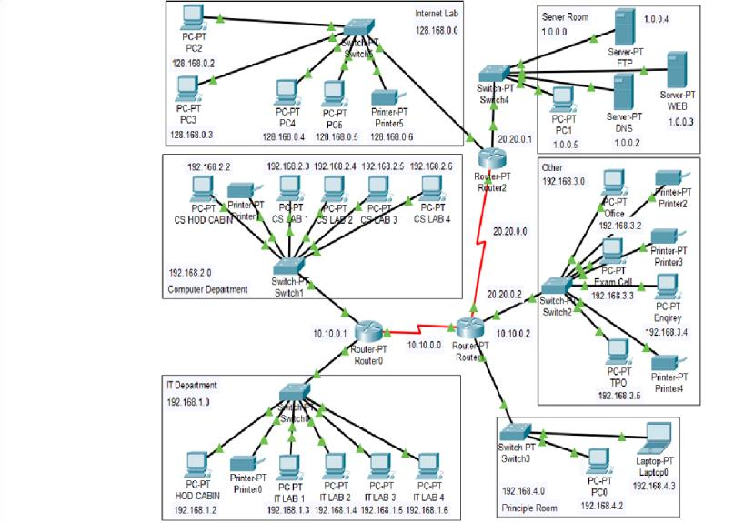Regular training and awareness programs: educational institutions should conduct regular training and awareness programs for faculty, staff, and students to educate them on the importance of network security and how to keep the network safe. This would help to prevent accidental or intentional breaches of network security.

1. Disaster recovery plan: educational institutions should have a disaster recovery plan in place in case of a security breach or network failure. This would involve backing up data regularly and having a plan in place to recover from any data loss.

By following these steps, educational institutions can ensure that the design and simulation of a secure campus network is implemented in a safe and responsible manner. This would help to prevent any security breaches and ensure that the network is reliable and available when needed.

V. NETWORK TOPOLOGY:

## VI. RESULTS

The designed and simulated secure campus network using Cisco Packet Tracer provides a reliable and secure network infrastructure to meet the requirements of educational institutions. The network topology is scalable, and the implemented security measures ensure the confidentiality, integrity, and availability of data.

|  |
| --- |
| The simulation results demonstrate the Overall, the design and simulation of a reliability and security of the designed secure campus network is an ongoing network infrastructure. Through various process that requires regular updates and tests, we determined that the network maintenance to ensure that the network topology could handle the required number remains secure and reliable. Future work in of users, devices, and applications, with high this area can help to improve the availability and scalability. The implemented effectiveness of network security measures security measures provided protection and ensure that educational institutions can against unauthorized access, data breaches, continue to provide a safe and secure and other security threats. learning environment for their students.    CONCLUSION VIII. REFERENCES |

## AND FUTURE WORK

In conclusion, the design and simulation of a secure campus network using Cisco Packet Tracer software is critical for modern educational institutions. A hierarchical network topology design and implementation of appropriate security measures are necessary for providing a reliable and secure network infrastructure. Cisco Packet Tracer simulation tool can be used to test and evaluate the network's performance and security measures.

Future work in this area could focus on the use of emerging technologies such as SDN and machine learning algorithms to improve network security and performance. The integration of these technologies could help to create a more dynamic and adaptable network infrastructure that can respond to changing security threats.

Another area for future work could be the development of more comprehensive training and awareness programs to educate students and staff on network security best practices. This could help to improve the overall security posture of educational institutions and reduce the risk of security breaches.

Finally, the implementation of a disaster recovery plan could be further investigated and optimized to ensure that educational institutions can recover quickly from any security breach or network failure. This could involve the use of cloud-based backup solutions and the development of more comprehensive disaster recovery strategies.

Here are some references for the above synopsis:

Xiang, Y., Chen, H., Huang, J., & Liu, B. (2019). Design and implementation of secure campus network based on Cisco

Packet Tracer. Journal of Physics:

Conference Series, 1196(3), 032070.

Chen, S., Wu, Y., Wang, Y., & Xu, X. (2018). Research on the security challenges and solutions of campus network. Journal of Physics: Conference Series, 1026(1), 012047.

Liu, Y., Lu, Y., Zhang, C., & Tian, J. (2020). Simulation-based network security scenarios training using Cisco Packet Tracer. Journal of Physics: Conference Series, 1546(1), 012078.

Cisco Packet Tracer. (n.d.). Retrieved

February 28, 2023, from https://www.netacad.com/courses/packettrac er.

Cisco. (2021). Cisco Security Architecture. Retrieved February 28, 2023, from https://www.cisco.com/c/en/us/solutions/en terprise-networks/securityarchitecture.html.

National Institute of Standards and Technology. (2018). NIST Special

Publication 800-53, Security and Privacy Controls for Information Systems and Organizations. Retrieved February 28, 2023, from https://nvlpubs.nist.gov/nistpubs/SpecialPu

blications/NIST.SP.800-53r4.pdf

**IEEE**